

Ref: CCC/CERT/16605/2015

<To2>

Service Certificate

Name of the Employee <name>

Nationality Pakistani

Designation <Designation>

Performance Good

Reason for Leaving Completion Of Project

Period of Service <From2> To <To2>

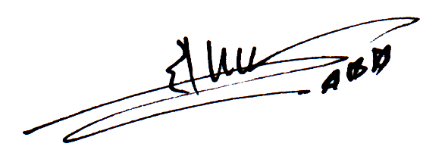

**Ch. Faqeer Muhammad**

**Managing Director**